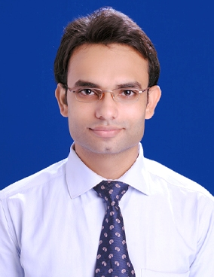
CARRICULUM VITAE

Roshan Dubey
Takiya para, near Nehru school,
Durg, chhattisgah.491001
Contact no- 9755383756, 9329028546
Email- dubey_roshan12423@rediff.com
.
PROFILE
Seeking for professional Bankers program After graduation Under national Institute of banking and finance.

EDUCATION
Year | Institution name | Exam name | School/college | Result | percentage
2008 | Chhattisgarh board of secondary education | high school certificate examination | Shri mahavir jain vidyalay durg | Passed | 66.80%
2010 | Chhattisgarh board of secondary education | higher secondary school certificate examination | Shri mahavir jain vidyalay durg | Passed | 73.40%
2013 | Pandit ravishankar shukla university raipur | graduation | Alliance institute of commerce & management | passed | 57.50%

Personal detail-

Date of Birth- 01-07-1993
Gender- male
Father's name- mr. pramod dubey
Father’s occupation- Advocate
Mother's name- mrs.veena dubey
Mother’s occupation- House wife
Nationality- Indian
Marital Status- single
Languages - English, Hindi,
Hobbies- playing badminton, Reading Newspaper, Watching TV.

Language-

English, hindi, local language

Computer skill
MS office, MS word, power point, MS excel

Strength-

Family and friends
Good verbal and written communication skill.
Able to work with hectic schedules.
Can work effectively within a team or as an individual.
Readiness to adopt new environment.

Declaration-

I hereby declare that the above information's are true to best of my knowledge.
PLACE: durg
DATE: 01-08-2014 Roshan dubey

